UPSKILLS DATA SCIENCE AND MACHINE LEARNING INTERNSHIP

WEEK - 5

ANU POLU

TALLA PADMVATHI COLLEGE OF ENGINEERING

# UPSKILLS DATA SCIENCE AND MACHINE LEARNING INTERNSHIP WEEK - 5

I would like to provide you with a progress report for my fifth week in the Upskills UCT

Machine Learning and Data Science Internship. The following points highlight the key aspects of

my activities and experiences:

# Project Overview:

The Smart City Traffic Pattern ML project aims to analyze and predict traffic patterns in a smart city environment using machine learning techniques. By understanding and predicting

traffic patterns, we can optimize traffic flow, improve transportation efficiency, and enhance overall urban mobility. This report provides an overview of the problem statement and discusses potential algorithms that can be employed in the project.

# Problem Statement:

You are working with the government to transform your city into a smart city. The vision is to convert it into a digital and intelligent city to improve the efficiency of services for the

citizens. One of the problems faced by the government is traffic. You are a data scientist working to manage the traffic of the city better and to provide input on infrastructure planning for the future. The government wants to implement a robust traffic system for the city by being prepared for traffic peaks. They want to understand the traffic patterns of the four junctions of the city.

Traffic patterns on holidays, as well as on various other occasions during the year, differ from normal working days. This is important to take into account for your forecasting.

Now we done the basic study of the PS and our dataset and evaluated the following facts about the given dataset and what we have to submit in the final project report. So, we will work accordingly.

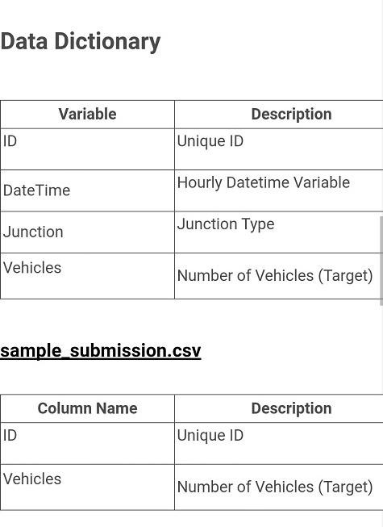

During Week 5, we focused on building and

**Progress Summary:**

validating our traffic forecasting model using Keras with Long Short-Term Memory (LSTM) architecture. The key activities and achievements are outlined below:

•

**Keras Modelling with LSTM:**

* Implemented a traffic forecasting model using the Keras deep learning library with LSTM architecture.
* LSTM is well-suited for sequential data such as traffic time series, as it can

capture temporal dependencies and patterns effectively.

•

**Root Mean Square Error (RMSE) as Cost Function:**

* Chose RMSE as the cost function for training our LSTM model.
* RMSE is a suitable choice for regression tasks, like traffic forecasting, as it

penalizes larger prediction errors more severely.

•

**Initialization of RNN:**

* Initialized the LSTM neural network with appropriate parameters and hyperparameters.
* Configured the number of LSTM units, the number of layers, and the activation

functions.

•

**Adding Input Layer and LSTM Layer:**

* Set up the input layer of the LSTM model, ensuring it is compatible with the reshaped and scaled training data.
* Added one or more LSTM layers to capture temporal dependencies and patterns in the data.
* Configured the output layer with appropriate activation functions based on the traffic forecasting task.
* **Fitting the RNN to Training Set:**Trained the LSTM model using the training set

generated from the preprocessed and reshaped data.

* Employed backpropagation and gradient descent optimization algorithms to update the model's weights and biases during training.
* Observed the model's performance on the training data and iteratively fine-tuned

the model based on RMSE and other evaluation metrics.

•

**Validating the Model:**

* Utilized the testing (or validation) set to evaluate the model's generalization performance.
* Calculated RMSE and other relevant metrics to assess the accuracy and efficiency of the trained LSTM model.
* Adjusted hyperparameters and made improvements based on the validation

results.

Moving forward, the following tasks will be undertaken in Week 6:

**Next Steps:**

•

**Hyperparameter Tuning:**

* Conduct further hyperparameter tuning to optimize the LSTM model's architecture and achieve better traffic forecasting accuracy.
* Explore different combinations of LSTM units, layers, learning rates, and batch

sizes to find the most suitable configuration.

•

**Integration with Real-Time Traffic Monitoring:**

* Integrate the validated LSTM model with the real-time traffic monitoring system to provide up-to-date traffic forecasts.
* Implement mechanisms to update the model with the latest real-time traffic data and adapt to changing traffic patterns.

•

**Continuous Evaluation and Improvement:**

* Monitor the model's performance in real-time and assess its effectiveness in traffic management.
* Gather citizen feedback and assess the impact of the implemented traffic

management strategies on overall traffic flow and congestion.

•

**Communication and Collaboration:**

•

**Challenges and Risks:**

* Fine-tuning hyperparameters and configuring the LSTM architecture may require significant computational resources and experimentation.
* Model overfitting or underfitting might occur, necessitating careful validation and

adjustment of the traffic prediction.

* The fifth week of our traffic management project marked

**Conclusion:**

significant progress in building an effective traffic forecasting model using Keras with Long Short-Term Memory (LSTM) architecture. By incorporating lag

features, scaling the input data, and leveraging the RMSE as the cost function, we have improved the model's ability to capture temporal dependencies and make accurate traffic predictions.

* The addition of lag features allowed the LSTM model to consider historical traffic patterns, contributing to more accurate forecasts. Proper feature scaling with Min- Max Scaler and Standard Scaler ensured that all features were on a similar scale, preventing any bias in the model training and ensuring convergence.
* Furthermore, we successfully split the dataset into training and testing sets, adhering to the temporal order of the data. This allowed us to effectively evaluate the model's performance and make fine-tuning adjustments during training.
* In the subsequent phase, we designed and implemented the LSTM neural network with appropriate parameters and hyperparameters. By adding input layers and

LSTM layers, we enabled the model to capture temporal dependencies and

patterns in the sequential traffic data. The choice of RMSE as the cost function for training was well-suited to the traffic forecasting task, penalizing larger prediction errors more significantly.

* By fitting the RNN to the training set and validating the model on the testing (or validation) set, we assessed the LSTM model's performance and iteratively fine- tuned it to achieve better forecasting accuracy. This validation process allowed us to gauge the model's generalization capabilities and make necessary

improvements.

* Looking ahead to Week 6, we plan to conduct further hyperparameter tuning to optimize the LSTM model's architecture and enhance traffic forecasting accuracy. The integration of the validated LSTM model with the real-time traffic monitoring system will enable us to provide up-to-date traffic forecasts and adapt to changing traffic patterns dynamically.
* Moreover, we will continue collaborating closely with infrastructure planning teams and stakeholders, sharing accurate traffic forecasts and insights. This

alignment of traffic management strategies with the model's predictions will guide

future infrastructure decisions and foster the development of a smart city with efficient traffic management.

* As we move forward, continuous evaluation and improvement will remain crucial in ensuring the effectiveness of the implemented traffic management strategies. We will closely monitor the model's performance in real-time and gather citizen feedback to assess the impact of our initiatives on overall traffic flow and congestion reduction.
* Overall, the progress made in Week 5 sets a solid foundation for the subsequent stages of the project, paving the way for a comprehensive traffic management system that aligns with the goals of transforming our city into a smart and efficient urban environment.

**Thanks and Regards**

**ANU POLU**